**Name : Roshani Gupta**

**Roll No : A018**

1. Open the Amazon SageMaker at [https://console.aws.amazon.com/sagemaker/.](https://console.aws.amazon.com/sagemaker/) 2. Choose **Notebook instances**, and then choose **Create notebook instance**.

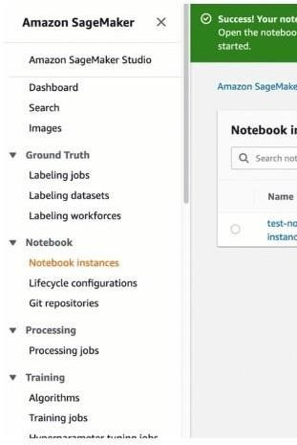

1. On the **Create notebook instance** page, provide the following information (if a field is not mentioned, leave the default values):

* 1. For **Notebook instance name**, type a name for your notebook instance.
  2. For **Notebook Instance type**, choose ml.t2.medium. This is the least expensive instance type that notebook instances support, and is enough for this exercise. If a ml.t2.medium instance type isn't available in your current AWS Region, choose ml.t3.medium.
  3. For **Platform Identifier**, choose a platform type to create the notebook instance on. This platform type defines the Operating System and the JupyterLab version that your notebook instance is created with. For information about platform identifier type, see [Amazon Linux 2 notebook instances.](https://docs.aws.amazon.com/sagemaker/latest/dg/nbi-al2.html) For information about JupyterLab versions, see [JupyterLab versioning.](https://docs.aws.amazon.com/sagemaker/latest/dg/nbi-jl.html)
  4. For **IAM role**, choose **Create a new role**, and then choose **Create role**. This IAM role automatically gets permissions to access any S3 bucket that has sagemaker in the name. It gets these permissions

through the AmazonSageMakerFullAccess policy, which SageMaker attaches to the role.

* 1. Choose **Create notebook instance**.

a. In a few minutes, SageMaker launches a notebook instance and attaches a 5 GB of Amazon EBS storage volume to it. The notebook instance has a preconfigured Jupyter notebook server, SageMaker and AWS SDK libraries, and a set of Anaconda libraries.

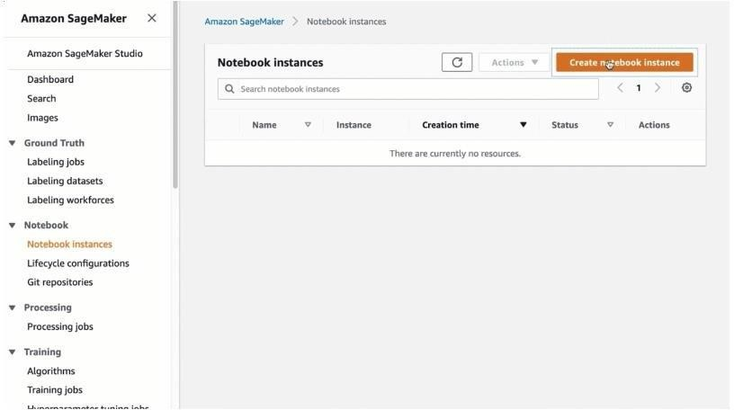

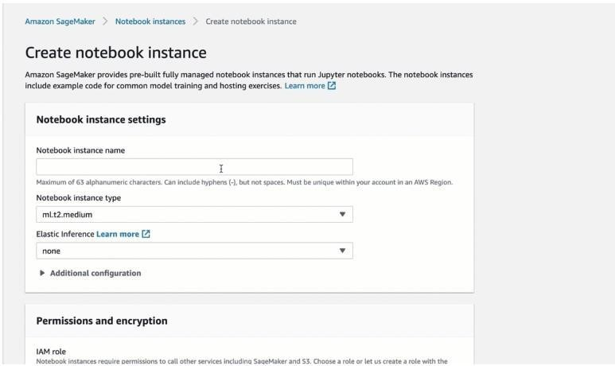

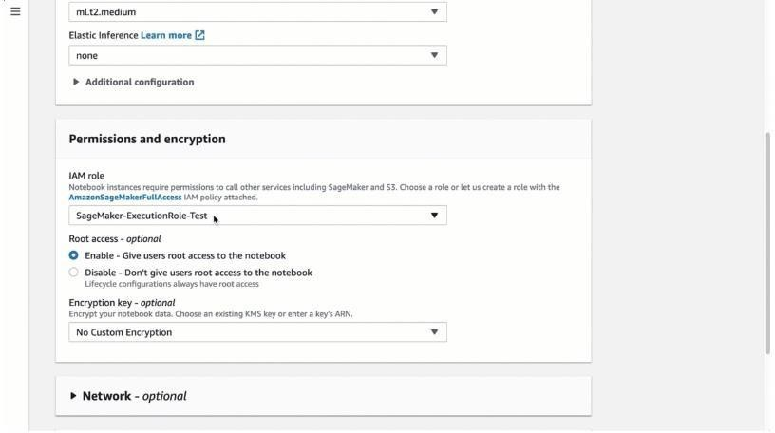

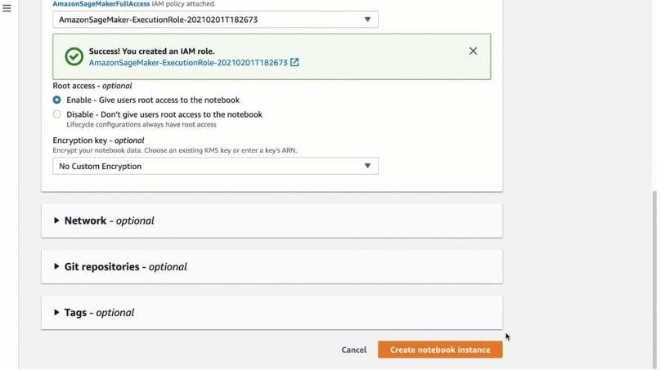

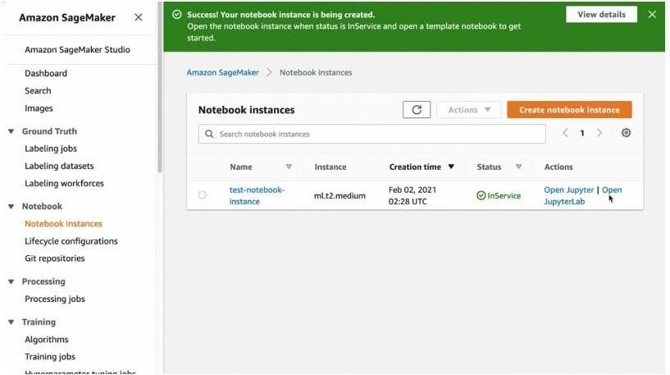

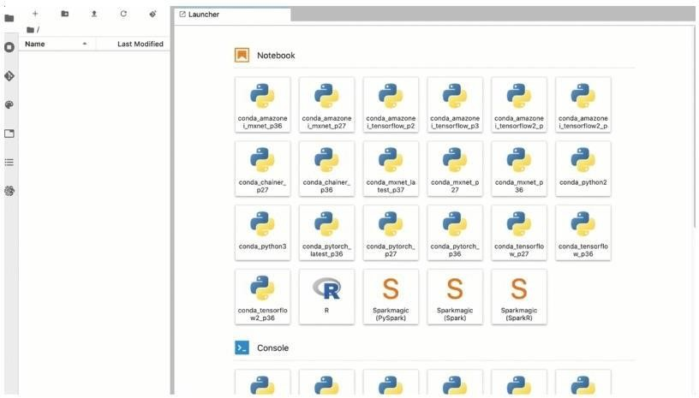

• Here have opened jupyter lab, we can also use jupyter notebook as well